LAB SHEET


K.R. MANGALAM UNIVERSITY SOET
(School of Engineering & Technology) B.TECH CSE (CORE)
Database & Management System Lab (ENCS254)

Submitted by- Submitted to-
Jony Gautam Mansi Kajal
Roll no - 2401010032`

LAB SHEET - 3
Objectives
- To understand the use of COMMIT and ROLLBACK commands in transaction control.
- To use ORDER BY and GROUP BY clauses in SQL queries.
- To understand DCL commands (GRANT, REVOKE) and the use of SAVEPOINT.
- To understand and implement JOIN operations in SQL.

Commands:

  - • TCL commands: COMMIT, ROLLBACK, SAVEPOINT are used to control transactions.
  - • DCL commands: GRANT and REVOKE are used to give or remove user privileges.
  - • GROUP BY is used for aggregation.
  - • ORDER BY is used for sorting.
  - • JOIN is used to combine data from multiple tables.

DDL Commands
    - Create TEACHER Table
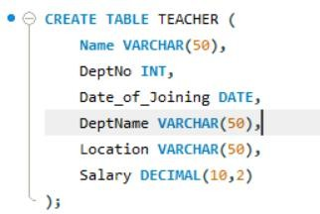

    - Create SALES Table
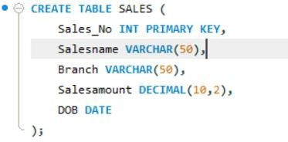
    - Create DEPARTMENTS Table
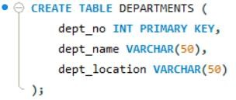

    - Create DEPARTMENTS Table
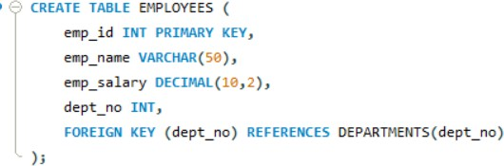

DML Operations

    - Insert 5 Records
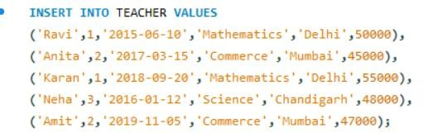

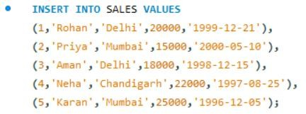

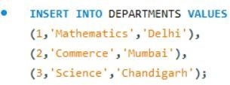
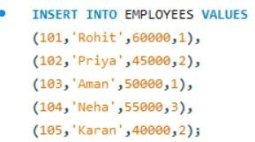

    - 25% Increment for Mathematics Department
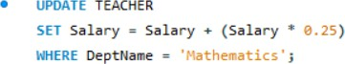

    - 15% Increment for Commerce Department
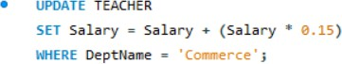

From SALES Table
    - Total Sales in Each Branch
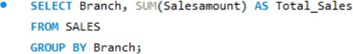

Output:
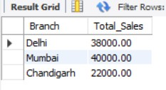

    - Average Sales in Each Branch
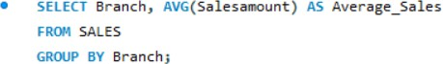
Output:
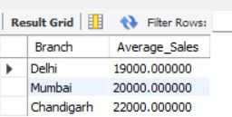

    - Salesname and DOB (Born in December)
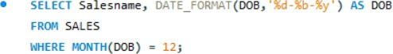

Output:
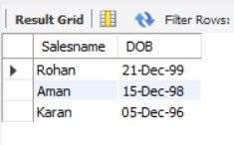

    - Salesname and DOB in Alphabetical Order of Month
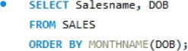

Output:
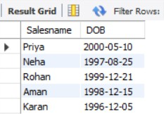

JOIN Operations
    - Employee and Department Details (INNER JOIN)
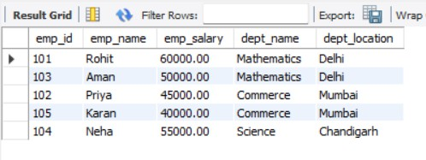
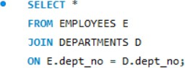

Output:
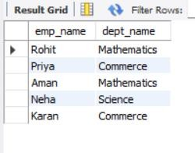

    - LEFT OUTER JOIN
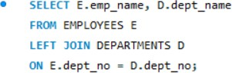

Output:
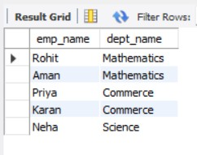
    - RIGHT OUTER JOIN
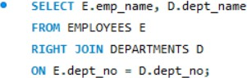

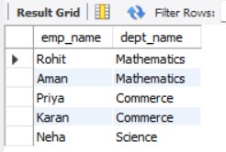

    - Employees with Salary Greater than Average
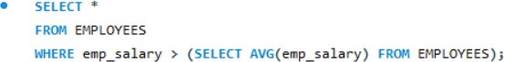

Output:
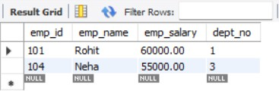

TCL Commands
    - ROLLBACK
    - COMMIT
    - SAVEPOINT
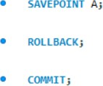

DCL Commands
    - Grant All Privileges
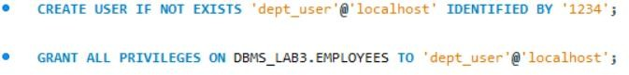

    - Grant Selected Privileges

    - Revoke All Privileges

    - Revoke Selected Privileges

